|  |  |
| --- | --- |
| **Variance** | **Standard Deviation** |
| Measures how much the numbers are spread out from the mean but harder to interpret because it’s in squared units.( hours², meters²). | More practical for understanding and communicating the spread of data. because it’s in the same units as the data (e.g., hours, meters). |
| Used in calculations like analysis of variance (ANOVA), regression analysis, etc. | Often used in everyday contexts, such as measuring how spread out test scores or heights are. |

**Variance (Population):**

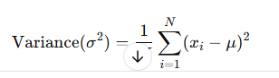

here:

* N = Number of data points in the population
* Xi = Each individual data point
* Μ = Mean of the population

### ****Variance (Sample)****:

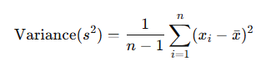

Where

* n = Number of data points in the sample
* xi​ = Each individual data point
* xˉ = Mean of the sample

